**Temasek Polytechnic**

**School of Informatics and IT**

**Diploma in Information Technology (IT)**

**AY2013/2014 Oct Semester Level 3**

**MP Terms of Reference**

**Project Particulars**

|  |  |
| --- | --- |
| **Supervisor** | **Yeak Shaw Wen** |
| **Project ID** | **MP19** |
| **Project Title** | **Sembawang Secondary School 2** |
| **Type** | **□ External & Tote □ External**  **□ Internal & Tote □ Internal** |
| **Category** | **□ Information Systems □ E-Learning**  **□ Electronics Commerce □ Games**  **□ Others** |

**Project Team’s Particulars**

|  |  |
| --- | --- |
| **Matric Number** | **Student Name** |
| **11102407B** | **Lim Yi Han** |
| **1100014H** | **Philbert Tan Jin Kiat** |
| **1101892F** | **Cheng Jun Ming** |
| **1104046F** | **Wei Xiang** |

# 

Table of Contents

**1. Introduction** 3

**2. Objectives of the Project** 3

**3. Scope of the Project** 4

**4. Distribution of Workload** 5

**5. Constraints** 7

**6. Resources** 7

**7. Product Positioning in the Market/Company** 8

7.1 Like iDAT 8

7.2 Unlike iDAT 9

7.2.1 Different Target Users 9

7.2.2 Informative with Meal and Exercise Recommendation 9

7.2.3 Weight Goal for all type of users 9

7.2.4 Meal Grading 9

7.2.5 In-depth Reporting 10

**8. Approach and Methodology of the Project** 10

**9. Glossary** 12

**10. Reference List** 14

# **1. Introduction**

Sembawang Secondary School have always been very concern about their students’ physical health being. The school is keen to promote the importance of healthy lifestyle by encouraging their students to pursue and engage in physical activities. The school have implemented a series of health programmes such as TAF Club, ACES Day, and Sports Carnival etc. to raise the fitness level of student and to reduce the number of obese students.

However, these series of health programmes implemented failed to highlight to the students about the importance of maintaining a healthy lifestyle. Hence, obesity and poor fitness level among students is still a persisting problem. Sembawang Secondary School have raised its concern and worries about this issue, thus the school is looking for a better solution to tackle this issue.

In order to ensure that students are able participate avidly, enjoy a healthy lifestyle and raise their fitness level, a feasible solution is required.

# **2. Objectives of the Project**

The overall objectives of the project are as follow:

* To allow the students to lead a healthy lifestyle in a fun and interactive way
* To record student daily calories input by tracking the student’s daily diet.
* To alert student if the meal taken are not balanced with the aid of ‘My Healthy Plate’.
* To calculate the student’s BMI based on his/her age, gender, height, and weight and plot a BMI-for-age percentile chart
* To allow students to track their weight against their targeted weight and provide both weekly and monthly weight goals for students to achieve
* To recommend the type of food to consume and exercises to take for the students to give them a head start in achieving a healthy lifestyle
* To provide real-time(using GPS) calculation of duration, distance and total calories burned during an exercise session
* To display health related diseases that the students are at risk at based on individual report
* To remind the students to exercise more and be cautious with their food intake in order to make the mobile application more sustainable in the long run.
* To motivate student by having a Friends System so that they can challenge and update their peers with their latest activity.
* To generate daily/weekly report of the comparison of student’s food intake against their recommended daily allowances (RDA)
* To generate a daily/weekly report on the calories burned

# **3. Scope of the Project**

The proposed Android Mobile Application will cover the following features:

* Track the user’s weight against the user’s targeted weight, allowing the user to key in their current/targeted weight at any point of time.
* Track the user’s diet by allowing the user to key in their daily diets at any point of time.
* Calculate the maximum calories needed by the user each day based on the user’s height, weight age and gender.
* Monitor the user’s daily calories intake and calories burned and compared it with their maximum calories needed for a day of activities.
* Perform real-time tracking (with GPS) of user’s exercise duration, walking/running distance, and calories burned. Manual input of the exercise done is allowed if GPS function is not available.
* Consolidate user’s daily performance into an intelligence report as a guide for user to know how well they are doing daily and what can they do to help themselves maintain a much healthier lifestyle.
* Provide users with comprehensive guides on how to gain or lose weight safely, information on the benefits of maintaining a healthy lifestyle, and the risk that user might face if they are underweight or overweight.
* Recommend possible meal and exercise that the user should eat or take in order to achieve their targeted weight goal.
* Set user‘s targeted weight goal (not more than one kilogram weight loss) based on their weight range (Underweight, Acceptable Weight, Overweight).
* Grade the daily meal that the users have chosen to indicate that the meal is a balanced or unbalanced meal based on my healthy plate criteria.
* Generate a detailed report for teachers to monitor student’s health so that they can encourage students to increase their fitness level by participating actively in physical activities.
* Integrate social features such as friend system, news feed and challenges to provide a fun and interactive experience for the users.

# **4. Distribution of Workload**

|  |  |
| --- | --- |
| **Objectives/Deliverables** | **Members** |
| 1) Design the Use Case Model for the mobile application  2) Design the Workflow and Sequence Diagram for the *Diet Tracker*, and *Challenge System*.  3) Design the Database design, ERD diagram, and VOPC models for the *Diet Tracker*, and *Challenge System*.  4) Design the User Interface for the *Diet Tracker*, and *Challenge System*.  5) Program the back-end codes of the mobile application for *Diet Tracker*, and *Challenge System*.  6) Test the mobile application for *Diet Tracker*, and *Challenge System*. | Yi Han |
| 1) Design the Use Case Model for the mobile application  2) Design the Workflow and Sequence Diagram for the *Registration and Login*, *Exercise Tracker*, and *Friend System*.  3) Design the Database design, ERD diagram, and VOPC models for the *Registration and Login*, *Exercise Tracker*, and *Friend System*.  4) Design the User Interface for the *Registration and Login*, *Exercise Tracker*, and *Friend System*.  5) Program the back-end codes of the mobile application for *Registration and Login*, *Exercise Tracker*, and *Friend System*.  6) Test the mobile application for *Registration and Login*, *Exercise Tracker*, and *Friend System*. | Wei Xiang |
| 1) Design the Use Case Model for the mobile application.  2) Design the Workflow and Sequence Diagram for the *Informative area*, and *Challenge System*.  3) Design the Database design, ERD diagram, and VOPC models for the *Informative area*, and *Challenge System*.  4) Design the User Interface for the *Informative area*, and *Challenge System*.  5) Program the back-end codes of the mobile application for *Informative area*, and *Challenge System*.  6) Test the mobile application for *Informative area*, and *Challenge System*. | Jun Ming |
| 1) Design the Use Case Model for the mobile application *Weight Tracker,* and *News Feed*.  2) Design the Workflow and Sequence Diagram for the *Weight Tracker,* and *News Feed*.  3) Design the Database design, ERD diagram, and VOPC models for the *Weight Tracker,* and *News Feed*.  4) Design the User Interface for the *Weight Tracker,* and *News Feed*.  5) Program the back-end codes of the mobile application for *Weight Tracker,* and *News Feed*.  6) Test the mobile application for *Weight Tracker,* and *News Feed*. | Philbert |

# **5. Constraints**

List of Constraints that is to be expected from this project:

* **Unfamiliar with Android Application Development** - This is the first time that the team was exposed to development of an Android Mobile Application. It is something fresh and new to the team. It may require some time to familiarise with the various developing techniques and tools which are required for this particular project. This will in turn affect the planned schedule, resulting in falling behind the planned schedule.
* **Schedule constraint -** There is merely 8 weeks for the team to complete the entire project which include planning, analysing, designing and developing the Android mobile application. Furthermore, every phases of the project has to be restrained to fit in to the 8 weeks schedule. There is insufficient time to source and research for the most accurate data thus delaying the planned schedule.
* **Data Source Constraint -** The accuracy and the relevancy of the data source may not be accurate because most of the information such as the calories of different type of food, type of exercise for specific number of calories burned may had changed overtime. This indirectly affected the data used by the mobile application.
* **Scope constraint -** The scope listed in the documents is what the team have assumed to be achievable and some of the feature may not be fulfilled as there may be changes as the project moved on the constructive phrase.

# **6. Resources**

List of software that the project will need

* Eclipse 4.2.1
* Eclipse Java Development Tools 3.8.2
* Android Software Development Kit
* Android Developer Tools v22.3.0-887826
* Android Virtual Device Emulator
* Microsoft Word & Excel 2010/ 2013
* Tortoise SVN 1.8.4
* SVN in Eclipse (Subversive) 1.1
* SQLite 3.8.2

List of hardware that the project will need

* Desktop/Laptop
* Android Phone
* Data/USB cable

# **7. Product Positioning in the Market/Company**

|  |  |  |
| --- | --- | --- |
| **Mobile App Features** | ***iDAT*** | ***Proposed Mobile App*** |
| ***Weight Tracker*** |  |  |
| ***Diet Tracker*** |  |  |
| ***Monitor maximum calories required*** |  |  |
| ***Monitor calories intake and output*** |  |  |
| ***Exercise counter (****Both GPS and Manual****)*** |  |  |
| ***Social Feature (****Friend System, News Feed,**Challenge****s)*** |  |  |
| ***Daily Performance Report*** |  |  |
| ***Catered to teens aged 13-17*** |  |  |
| ***Informative with Meal and Exercise Recommendation (****Food Nutritional Table, Health Guides, Existing Risk etc.)* |  |  |
| ***Weight Goals Guide (****Gain* ***/*** *Lose* ***/*** *Maintain Weight****)*** |  |  |
| ***Grading of daily meal (****My Healthy Plate****)*** |  |  |
| ***Reports for Teacher to monitor Student’s Health*** |  |  |

## 7.1 Like iDAT

Our mobile application seeks to help user to monitor daily calories intake and output, their maximum calories required to achieve weight goals, and track their daily diet and weight. During exercise/activity, the mobile application will help track the duration, distance etc. using GPS or, allow user to manually key in the exercise/activity done if GPS is not available.

The mobile application make use of social features for user to add friends, track news feed of friends, and do challenges against other user’s personal record. A report or, summary is available for users to keep track of how well they are doing daily.

## 7.2 Unlike iDAT

### 7.2.1 Different Target Users

While iDAT is catered to users aged 18 and above, our mobile application is specially targeted for secondary students aged 13-17, helping them to achieve and maintain a healthy lifestyle in a fun and interactive way.

### 7.2.2 Informative with Meal and Exercise Recommendation

Although iDAT is a great combination of dietary and activity tracker, it did not include information for users on how one can gain or lose weight in a safe way(e.g. not by skipping meals) what does it mean to be healthy, what are the various health related risks that the user should take note of and they might fall in, what the user should eat to be considered as a healthy and balanced meal, or what are the available exercise options that user can participate in order to keep fit and stay in shape.

Our mobile app seeks to provide comprehensive information for user on how should they gain or lose weight in a safety manner, what meal or exercise should they take to achieve their weight goals, what are the health related issues that the user might face for being obese or underweight etc. and also to guide and encourage them to keep fit.

### 7.2.3 Weight Goal for all type of users

The weight goal function in iDAT is based on user’s current weight and their target weight, set a time range of how long the user needs to reach the target. However, if the user’s current weight is already in the acceptable range or, is underweight, the weight goal function will be disabled. The mobile application will instead provide the user with information as of how to maintain their weight with the help of a balanced diet and having an adequate amount of exercise.

Our mobile app seeks to have the weight goal function not only as a guide for overweight student to lose weight but also to help acceptable weight student to maintain weight, and help underweight student to gain weight to an acceptable range.

### 7.2.4 Meal Grading

On iDAT, users can add their daily meals consumed in order to have their food calories intake calculated. However, the user will not know if they are having a balanced meal based on the RDA and healthy plate criteria which is dependent on the user’s age and gender.

Our mobile application seeks to use ‘My Healthy Plate’ as a guideline to grade whether the user is having a balanced meal. Otherwise, a list of food will be listed for the user include in their meals.

### 7.2.5 In-depth Reporting

Reporting on iDAT is just a summary view of the user’s calories input and output each day with an indicator of how much more calories can the user consume based on their daily recommended allowances.

However, it is insufficient to indicate whether the user are really keeping fit as it did not show whether the user are has been exercising weekly etc.

Our mobile app seeks to have a reporting view on a daily and weekly basis to indicate whether the user has been working out, whether their dietary intake is acceptable, whether the user is consuming a balanced meal etc. There will also be a view for teachers to keep track of their student performances so that teacher can approach student to further encourage and motivate them to maintain a healthy lifestyle.

# **8. Approach and Methodology of the Project**

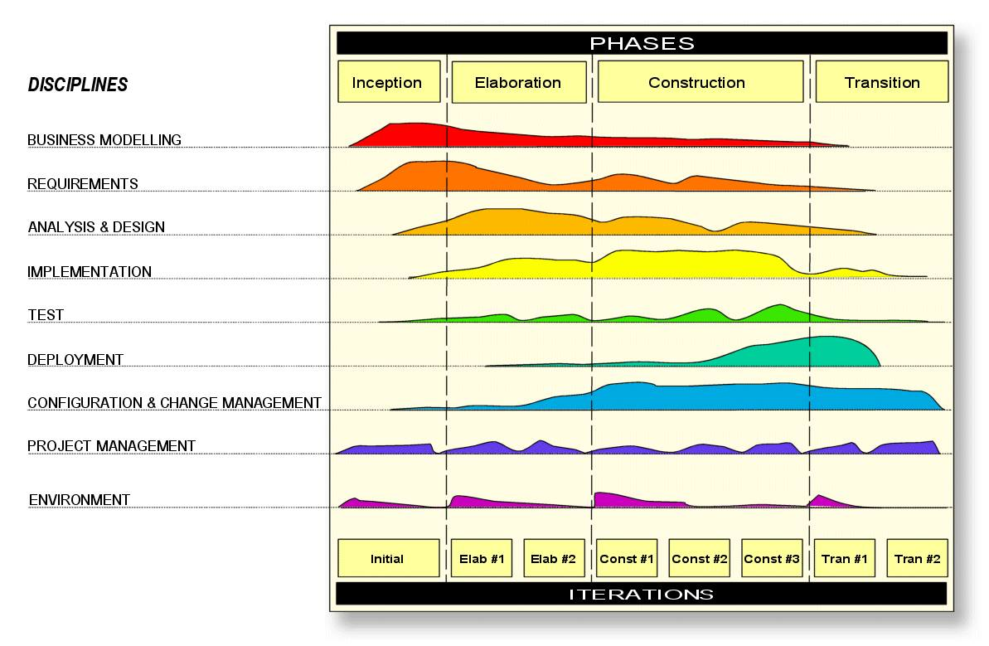

**Figure 1: Rational Unified Process**

The process model that will be adopted for the mobile application project will be Rational Unified Process (RUP). RUP promotes an iterative development by breaking down large amount of tasks and organised the development of software and systems into different phrases for easier analysis and planning for the team. Each of the phrases will consist of one or more iterations at that stage of development. This makes it a more suitable process to improve team productivity and quality.

**Risk of adopting RUP**

**Risk 1:** RUP requires a mind-set that is risks oriented, able to manage realistic expectations, and tolerate uncertainties. If the team does not have the mentality of crafting out a realistic schedule to handle any possible worst case scenarios, or handling the delivery of requirements not well enough, the development of the mobile application will eventually come to a halt.

**Solution:** Ensure that careful and comprehensive planning are done before the development of the mobile application. This helps the team to meet the required deadline and stay organised. Careful planning also helps to keep the team focused and stay on track, making sure that everyone in the team are aware of the progress. Furthermore, this will help to cater to any unforeseen circumstances.

**Risk 2:** RUP segregates the whole project into different segments. This may in turn affect the progress project because some of the iterations may be dependent on the other. The team might not be able to stay focus on one iteration at a time, causing disorganization among the team. This will eventually affect the team’s progress on a large scale since the team might have problem developing the mobile application.

**Solution:** Planning of the work breakdown between each iteration in different phrases ensures that the team does not need to go to iteration 2 to complete one task before going back to iteration 1 etc. This help to reduce confusion during the iteration. Subversion such as Tortoise SVN and Subversive helps to track what has been updated on the mobile application and the person who updated it, which prevent disorganisation between team members.

# **9. Glossary**

**A**

**B**

Body Mass Index (BMI) - Is a measure for human body shape based on an individual's mass and height.

**C**

Constraint - Something that being restricted or confined within prescribed bounds.

**D**

Deployment – activities that make a software system available for use

**E**

Exercise counter - Calculate total calories burned during and after exercising

**F**

**G**

**H**

Healthy Plate - To alert users when they are not having balanced meal for each meal

**I**

**J**

**K**

**L**

**M**

**N**

**O**

**P**

**Q**

**R**

Recommended Daily Allowances (RDA) - Comparing of student’s food intake

Rational Unified Process (RUP) - An iterative software development process framework created by the Rational Software Corporation a division of IBM.

**S**

Software Architecture – a static framework or skeleton that provides the form of a software system

**T**

Tester - To test whether the software is working accordingly as planned.

**U**

**V**

**W**

**X**

**Y**

**Z**

# **10. Reference List**

Developer Android. (n.d.). Retrieved from

<http://developer.android.com/sdk/index.html>

Hadding, E. (2007, May). *Volvo*.Retrieved from

<http://www.cse.chalmers.se/research/group/idc/ituniv/kurser/07/ucd/papers/4%20RUP_0705_RUP%20reflection.pdf>

IBM. (n.d.). *Best practices for design, implementation and effective project management*.

Retrieved from <http://www-01.ibm.com/software/rational/rup/>

My PM Expert*.* (2009). *The Advantage and Disadvantages/ Best Practices of RUP software Development* Retrieved from

<http://www.my-project-management-expert.com/the-advantages-and-disadvantages-of-rup-software-development.html>

Raizel Consulting . (2007, September 11).*The advantages of using Rational Unified Process in*

*Software Development.* Retrieved from

<http://raizelconsulting.com/whitepapers/The%20advantages%20of%20using%20Rational%20Unified%20Process%20in%20a%20Soft.pdf>

Spataru, A. C. (2010). *Agile Development Methods for Mobile Applications*. Retrieved from

<http://citeseerx.ist.psu.edu/viewdoc/download?doi=10.1.1.186.1292&rep=rep1&type=pdf>